 [Translated from German to English - www.onlinedoctranslator.com](https://www.onlinedoctranslator.com/en/?utm_source=onlinedoctranslator&utm_medium=docx&utm_campaign=attribution)

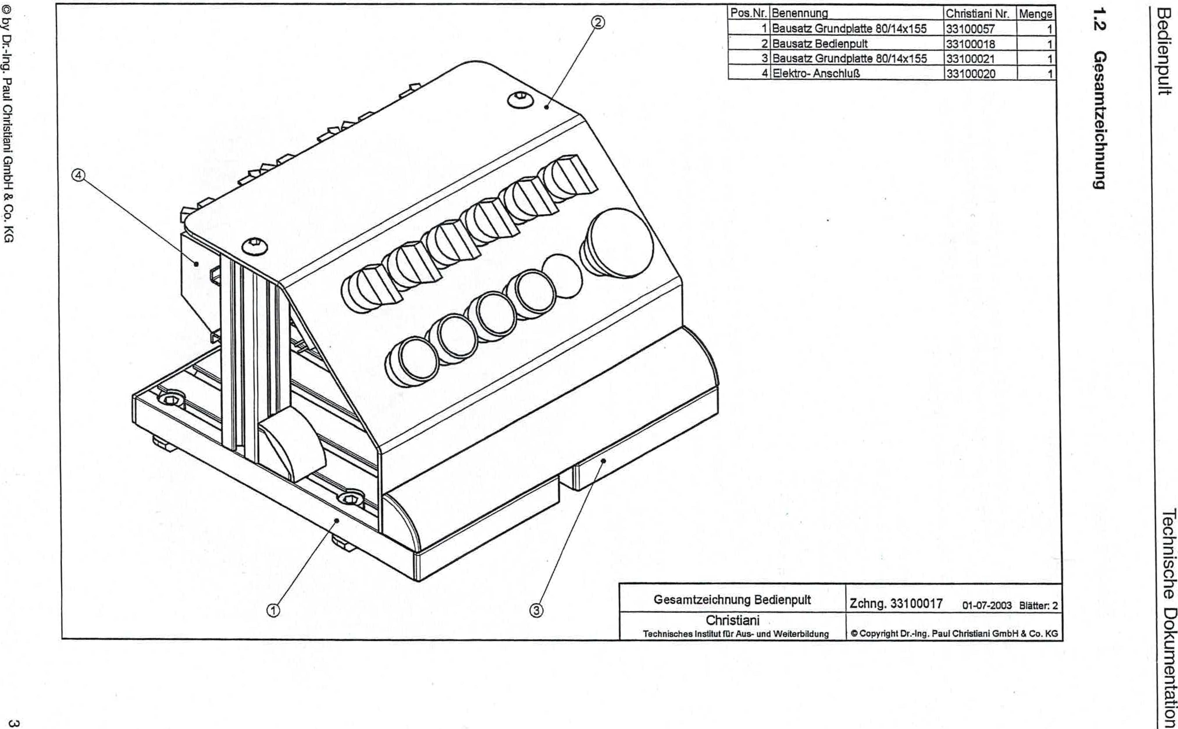

0 by Dr.-Ing. Paul Christiani GmbH & Co. KG

GJ

**6unutiopziwesap**

IV

GO CO

CO

-O

uoReluownmooetiospqoal

|  |  |  |  |
| --- | --- | --- | --- |
| Item No. | designation | Christiani No. | Crowd |
| 1 | Base plate kit 80/14x155 | 33100057 | 1 |
| 2 | Control panel kit | 33100018 | 1 |
| 3 | Base plate kit 80114x155 | 33100021 | 1 |
| 4 | Electrical connection | 33100020 | 1 |

General drawing of the control panel

Drawing 33100017 01-07-2003 Pages: 2

Christian'

Technical Institute (Ur Training and Further Education

©Copyright Dr.-Ing. Paul Christiani GmbH & Co. KG

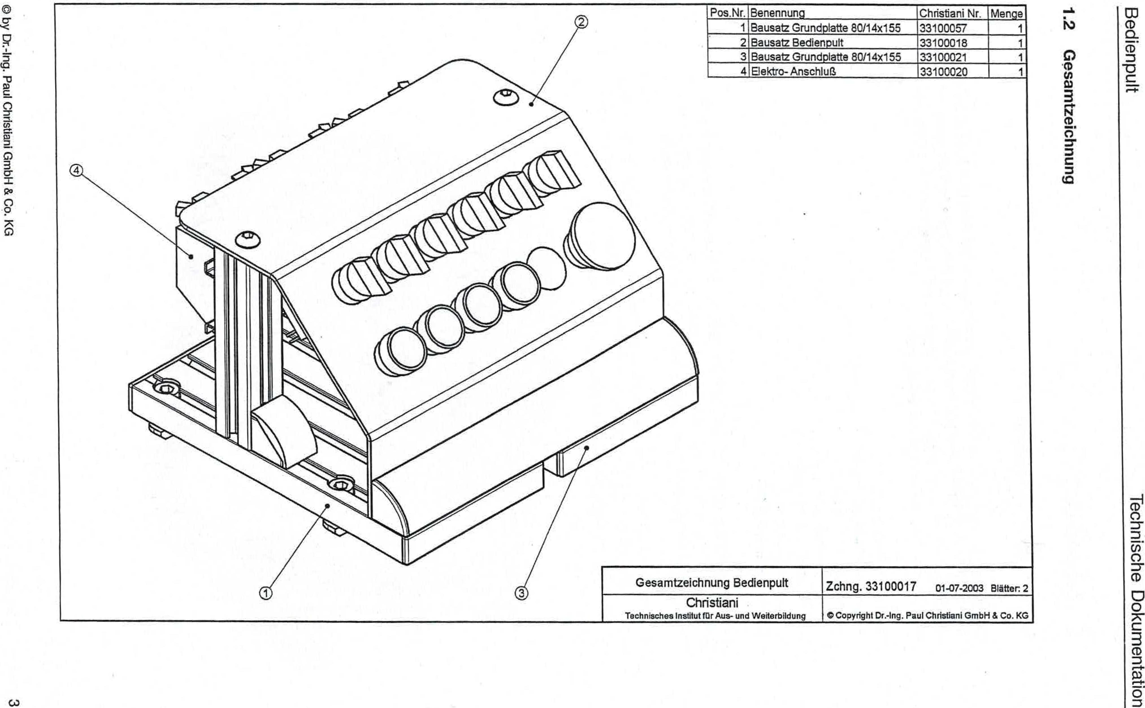

by Dr.-Ing. Paul Christiani GmbH & Co. KG

c)

**6unutp!azTwesa0**

COCO

a
  
CO3
  
-13

**r-+**

uopluawrimoo egospLpei

|  |  |  |  |
| --- | --- | --- | --- |
| Item No. | designation | Christiani No. | Crowd |
| 1 | Base plate kit 80/14x155 | 33100057 | 1 |
| 2 | Control panel kit | 33100018 | 1 |
| 3 | Base plate kit 80/14x155 | 33100021 | 1 |
| 4 | Electrical connection | 33100020 | 1 |

General drawing of the control panel

Drawing 33100017 01-07-2003 Pages: 2

Christiani

Technical Institute for Education and Training C Copyright Dr.-Ing. Paul Christiani GmbH & Co. KG

**1 Mechanics**

Control panel technical documentation

0 by Dr.-Ing. Paul Christiani GmbH & Co. KG 1

**1.1 Functional description**

The control panel functional module provides 10 switches and buttons, as well as an emergency stop switch, for operating one or more functional modules or stations. The following control elements are available for inputting and displaying signals:

1 x emergency stop switch

1 x illuminated push button green 1 x illuminated push button red

1 x illuminated push button switch blue 1 x illuminated push button switch clear 1 x toggle switch 1-0-2

1 x toggle switch 0-1

The functional module is completely built on a mounting platform measuring 180 x 200 mm and can be flexibly mounted individually or together with other functional modules on an aluminum profile plate.

Three 8-bit transfer connectors are available as interface modules for connecting to three digital PLC inputs and two digital PLC outputs. The supply voltage of the functional module is 24 VDC.

